**CSE260 Project Report**

Submitted by - Group: 8 ; Section: 12

**Project name:** Implement Traffic lights Using logic gates.

**Introduction:**

Traffic lights are used to maintain the vehicles movement. It gives signals to the vehicle to move and stop. As there are so many vehicles in our country, we need to create traffic lights as much as possible.

**Components Used:**

Bread board, Male to female connector, Battery, IC 74HC138, IC 7408, LED.

**Data Flow:**

We used IC 74HC138 ic to select the read. When we select a road the other road’s signal will be red. We used AND gate which will detect if the three road’s signal is on the other one will be green.

**Table and Diagram:**

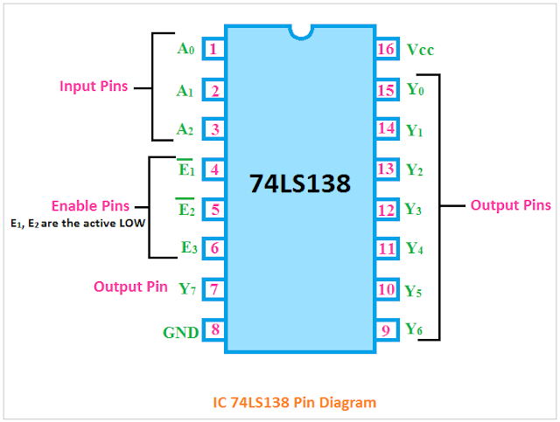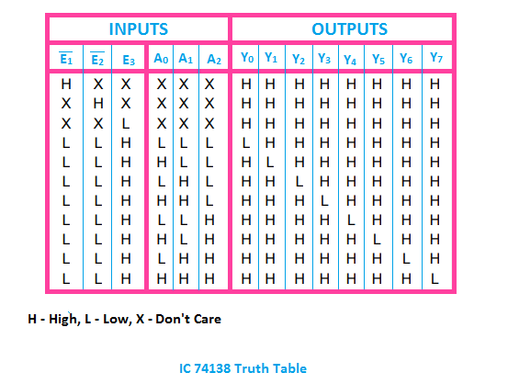

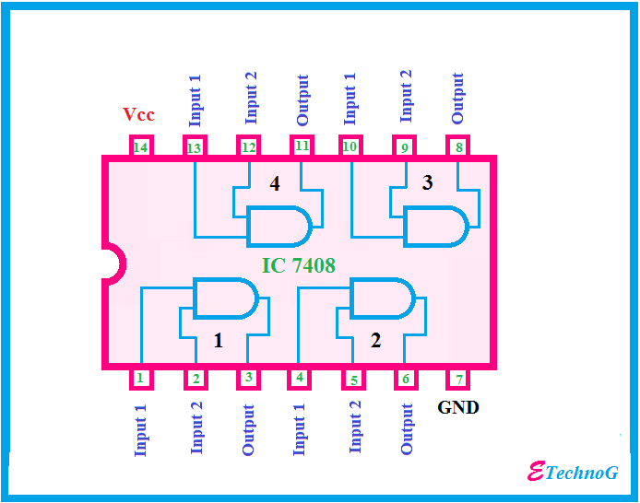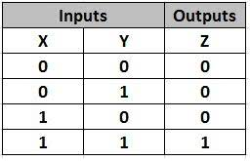

**Results:**

We can switch on only one road’s green light at a time. The other road’s red light will be on at that time.

**Total Cost:** 1400 Taka

**Limitations and Future Improvements:**

Sometimes people will not move according to the signal and they break the law. There should be a sensor that will detect if the vehicles are moving according to the signal or not.

**Conclusion:**

This project is based on a very effective way of optimizing traffic, with redefinition of threshold values for a real time application.This works to control traffic on four way roads according to traffic control barricades . This proposed system will be able to build a developed country with less traffic jams and it will also help the emergency vehicle to reach in time to the destination. So, this intelligent system will help us to control traffic in a more autonomous way.

**References:**

<https://www.kynix.com/components/74HC138-DECODER-DATASHEET-PINOUT-SCHEMATIC.html>

<https://www.brainkart.com/article/Verification-of-Truth-Tables-of-Logic-Gates-Using-Integrated-Circuits_38561/>